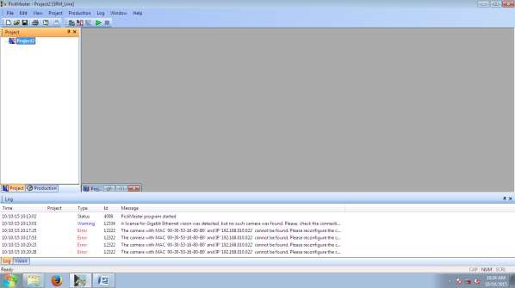

Figure 1: "New Project" window.

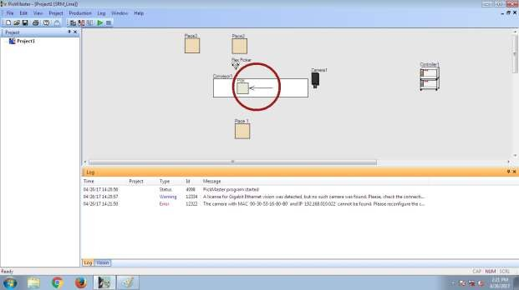

Figure 2: Default project layout.

Expt No:  07 | PARALLEL MANIPULATOR ROBOT (ABB IRB 360)
Date:
/ /2025

AIM:
To understand the offline, vision-guided programming of an ABB IRB 360 "FlexPicker" (a 4-axis parallel manipulator) for a high-speed conveyor-based palletizing task using PickMaster.

APPARATUS REQUIRED:
- Robot: ABB IRB 360 FlexPicker (Delta/Parallel Robot),
- Controller: ABB IRC5 Controller,
- Conveyor: Variable Frequency Drive (VFD) conveyor belt,
- Vision System: Ethernet-compatible camera,
- Software: PickMaster PC Software.

THEORY / PRINCIPLE OF OPERATION:
Unlike a serial robot, the IRB 360 is a parallel manipulator (Delta Robot). Its key feature is a closed-chain kinematic system where multiple arms connect the fixed base directly to the moving platform (end-effector). This design results in lower moving mass, leading to extremely high speed and acceleration, which is ideal for "pick and place" tasks.
- Offline Programming: This experiment utilizes "offline" programming. Instead of teaching a physical robot, the entire work cell (robot, conveyor, camera) is simulated in a PC / PickMaster. The program is developed virtually and then downloaded to the controller.
- Vision-Guided Robotics: The system is "un-calibrated" in that it does not know where the objects will be. A camera (Position Source) identifies objects "on the fly," and the PickMaster software dynamically calculates their X, Y, and orientation coordinates.
- Conveyor Tracking: This is the core principle. The software must calculate a future intercept path for the robot. It identifies an object at one point, tracks its movement based on the conveyor's known speed (from the VFD), and commands the robot to match the speed and position of the object for a successful "pick" while it is still in motion.

PROCEDURE:
- Open PickMaster software. Select "New" (as shown in Figure 01).
- The default layer appears (as shown in Figure 02).
- Right-click on the layout to get the following options: Object and Pick position.
- Select the objects and place them on the screen (as shown in Figure 03). Rename them as "SRM" and "ABB" respectively.
- Select the container by right-clicking on the screen (as shown in Figure 04).
- Select at least two "position sources" by right-clicking on the main screen and dropping them (as shown in Figure 05).
- Edit each position source's properties by double-clicking its icon. This can be done using one of the following methods:
  - Blob detection
  - Geometric
- Create a template and assign the drop position, which is the position source for picking the objects (as shown in Figure 06).
- Create a pattern for placing accepted objects by selecting the "container configuration" (as shown in Figure 07).
- Click the "run" button in the main screen for execution of the project.

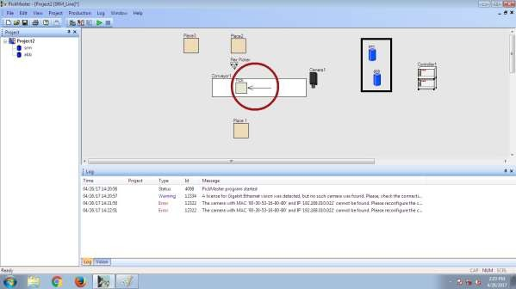

Figure 3: Layout with objects ("SRM", "ABB") added.

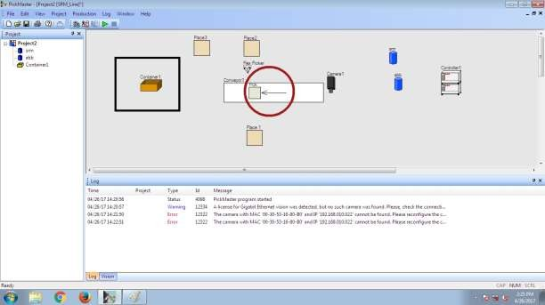
Figure 4: Layout with container added.

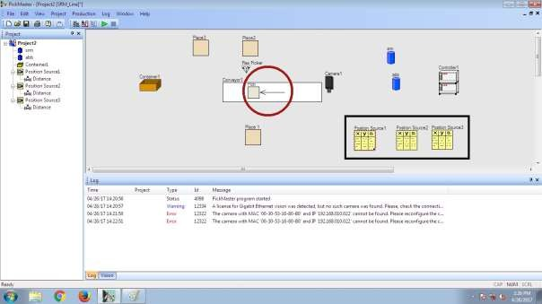

Figure 5: Layout with position sources added.

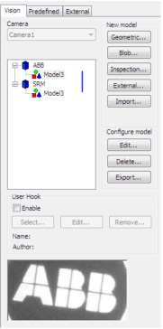

Figure 6: Vision template creation ("Geometric" or "Blob").

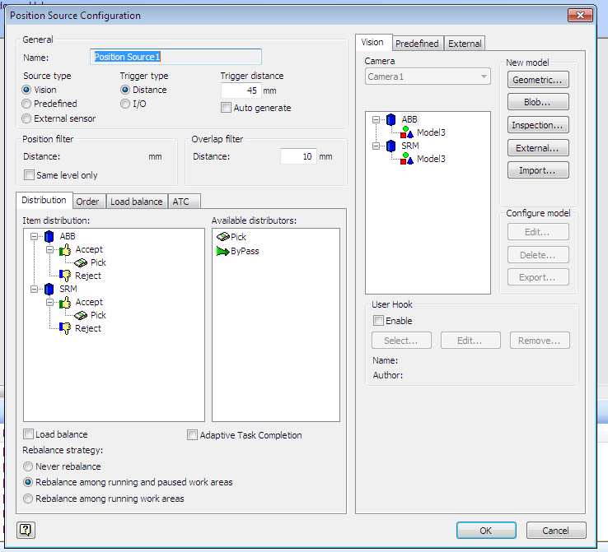

Figure 7: Position source configuration (Item distribution).

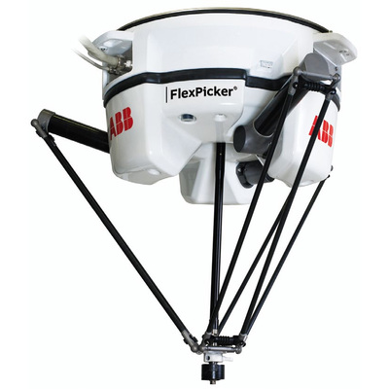

Figure 8: ABB IRB 360 Industrial Robot.

RESULT:
The high-speed, vision-guided palletizing task was successfully configured. The experiment demonstrated that programming a parallel robot for conveyor tracking is an offline, software-centric task that relies on vision systems to define "pick" coordinates dynamically and pre-defined patterns to define "place" coordinates.

